RESEARCH STUDY Open Access

ANALISIS SPASIAL TERHADAP POTENSI PENCEMAR CAIR DALAM DOKUMEN UKL-UPL BERJENIS INDUSTRI DI KABUPATEN JOMBANG

SPATIAL ANALYSIS OF LIQUID POLLUTANT POTENTIAL IN INDUSTRIAL TYPE UKL-UPL DOCUMENTS IN JOMBANG REGENCY

Naufal Hilmy Amanur Qolby¹, Lilis Sulistyorini², Muhammad Rosyid Ridlo³

ABSTRAK

Latar Belakang: Pendirian industri baru sering dikaitkan dengan potensi limbah yang akan diproduksi dan masalah lingkungan yang mungkin timbul karena kegiatan yang dilakukan oleh industri di masa yang akan datang. Salah satu dari banyak masalah lingkungan karena limbah industri adalah polusi air, udara, dan tanah di daerah di mana industri ini berada. Jumlah pengajuan UKL-UPL berjenis industri di Kabupaten Jombang dari 2006-2020 terlihat tidak stabil tetapi cenderung meningkat dari 2015-2020. Kabupaten Jombang adalah area hilir Sungai Brantas yang kualitas airnya menurun dari 49,17 pada 2015 menjadi 47,68 pada 2016.
Tujuan: Tujuan dari penelitian ini adalah untuk menganalisis secara spasial lokasi industri yang memiliki potensi untuk polutan cair dan distribusi sungai di Kabupaten Jombang.
Metode: Penelitian ini menggunakan desain penelitian observasional dengan pendekatan deskriptif kuantitatif dengan model analisis spasial. Data yang digunakan adalah data sekunder, yaitu data pengajuan UKL-UPL Kabupaten Jombang pada tahun 2006-2020, data lokasi industri, dan data spasial sungai di Kabupaten Jombang.
Hasil: Rencana pembentukan industri di Kabupaten Jombang sebagian besar berpusat di sekitar ibukota kabupaten itu sendiri. Sungai di Jombang cenderung lebih panjang di kecamatan-kecamatan yang terletak di utara dan selatan. Tidak ada perbedaan yang signifikan pada lokasi rencana pendirian industri ke sungai terdekat untuk industri dengan dan tanpa potensi polutan cair (0,912 <0,05)
Kesimpulan: Meskipun kecamatan dengan jumlah industri tinggi memiliki panjang sungai yang lebih pendek, pemantauan kualitas air sungai biasa harus dilakukan sehingga tidak melebihi standar kualitas lingkungan dan menyebabkan masalah kesehatan.

Kata kunci: pencemaran air, sungai, lokasi industri, SIG

ABSTRACT

Background: The establishment of new industries is often associated with potential waste to be produced and environmental problems that may arise due to the activities carried out by the industry in the future. One of many environmental problems due to industrial waste is the pollution of water, air, and soil in the area around where the industry is located. The number of industrial types UKL-UPL submissions in Jombang Regency from 2006-2020 is unstable but tend to increase from 2015-2020. Jombang Regency is a downstream area of the Brantas River which its Water Quality Index has decreased from 49.17 in 2015 to 47.68 in 2016.
Objectives: The purpose of this study was to analyze spatially the location of the industry that had the potential for liquid pollutants and river distribution in Jombang Regency.
Methods: This study uses observational research design with a quantitative descriptive approach with a spatial analysis model. The data used is secondary data, namely the submission data of Jombang Regency UKL UKL document in 2006-2020, coordinate data of the location of the industry, and spatial river data.
Results: Industrial establishment plans on Jombang Regency are mostly centered around it’s regency seat. The length of rivers in Jombang tend to be longer in the northen and sourthern sub-districts. There is no significant difference on the location of industrial establishment plan to the nearest river for industries with and without liquid pollutant potentials (0.912 < 0.05).
Conclusions: Even thought sub-districts with high industry counts has shorter river length, regular river water quality monitoring is required to be done so that it doesn’t exceed environmental quality standards and cause health problems.

Keywords: water pollution, river, industry location, GIS

*Koresponden:
naufalqolby@gmail.com
Naufal Hilmy Amanur Qolby
^{*1}Bachelor Program of Public Health, Faculty of Public Health, Universitas Airlangga, Surabaya 60115, Indonesia
²Department of Environmental Health, Faculty of Public Health, Universitas Airlangga, Surabaya 60115, Indonesia
³Section of Environmental Impact Review, Jombang Regency’s Environment Office, Jombang 61419, Indonesia

INTRODUCTION

Industrialisation is a crucial phase for developing countries to increase their prosperity, solving unemployment problems, and to increase work productivity which is tied to low income (Damayanthi, 2008). Because of efficiency factor in economic world, industrialisation process would use resources as much as possible and will be processed maximally so that their waste is so dense and harmful to the surrounding environment. This industrialisation supported modernization is predicted to give heavy impact to the environment because of resources deficit accompanied by environmental polution with a rate that is getting faster (Muliani and Rijal, 2018). Environment-friendly industrialisation and integrated waste management are becoming important thing because this synergy will give benefit for both industries in macro and micro scale. Not only that but this will contribute to industrialisation’s survival itself but also keep the environtment from pollution threat. The high population in urban areas is resulting in an increase in solid and liquid wastes (Mushthofa, Rudiyanti and Muskanonfola, 2014). River is an aquatic ecosystem which has important role in hydrological cycle and functioning as water catchment area for surrounding area, that means a river condition is dependent to its surrounding area characteristics. If the activity surrounding the river is balanced with high public awareness to conserve environtment of river, then it’s water quality will be relatively good and vice versa (Yogafanny, 2015; Diari Sandi and Hariyanto, 2019). The disposal of waste often done on river area which is considered to be able to flow the waste elsewhere (Diari Sandi and Hariyanto, 2019). The usage on river body of water for industrial and domestical use are resulting in the decreasement of river’s water quality index (Nasir, Fatkhurohman and Muqorobin, 2011). Any kind of waste should not be a problem if it is well managed, but sometimes because of limited funding and the lack of concern from the industry’s business actors those waste are poorly managed, so sooner or later will cause problems in the future (Nasir, Fatkhurohman and Muqorobin, 2011; Widiyanto, Yuniarno and Kuswanto, 2015). With the disposal of various types of wastes that contain many kind of pollutants including those that can be broke down or not to the river’s body of water causing the river’s load to be heavier (Uyara, Kunu and Talakua, 2017). The poor quality of river water will have an impact on the decline in the number of river biota and in general it will further reduce the quality of river water in the downstream which then leads to the sea (Yogafanny, 2015). Jombang Regency has a downstream area from the Brantas River and also traversed by two big rivers which are Konto River and Gunting River that is a sub-drainage basin of Brantas River (Bappeda Jawa Timur, 2013). Information from East Java’s Environmental Services Office is that WQI in East Java Province is decreasing, from 52,51 in 2015 to 50,75 in 2016, both numbers are in “Very Poor” status. Other than that WQI of Brantas River which have downstream in Jombang Regency is also having a decreasement, from 49,17 in 2015 to 47,68 in 2016. (Dinas Lingkungan Hidup Jatim, 2018) UKL-UPL is an effort that function as a reference in managing and monitoring environment by the person in charge for business, it is also a requirement to acquire the permit to establish a business that doesn’t require AMDAL. This environmental managing and monitoring must be done for a business activity from planning, construction, operation, and even post-operation phase (Kementrian Lingkungan Hidup dan Kehutanan, 2010). Geographical Information System (GIS) is a system that integrates various physical resources, logical calculations, and analysis related to real earth’s surface objects. This computer software can process, input, save, manipulate, display, and produce geographical information. Geographical Information System (GIS) is often used to help in settlement planning because it can integrate geographical and tabulation (text and number) data that enable to make analysis and prediction about wanted phenomenon as planning information (Aqli, 2010). Jombang Regency’s Environment Office record general description of the submitted UKL-UPL documents such as business name / activity, address, type of activity, and potential pollutants that can be caused by the business activity. With the help of GIS, we will reveal the distribution of selected variables that can’t be done with other statistical methods. This study aimed to determine industry distribution map and river length in Jombang Regency from 2006 to 2020.

METHOD

This study was an observational research with quantitative descriptive approach using spatial model analysis. All data used in this research are sourced from Jombang Environtmental Office for bussines activities submission summary, Google Earth for industries coordinates, and Indonesia Geospatial Portal website for Jombang Regency’s spatial data. Total submitted business activity recorded on submission summary from 2006 to 2020 is 665 documents in which industrial-type business activity is the most common one with 160 documents (24,1%) followed by telecomunication towers with 143 documents (21,5%) and clinics with 80 documents (12%) and the rest are 280 documents (less than 10% each business type). Industrial type business activity documents consist of Adendum ANDAL RKL documents (0,6%), AMDAL documents (1,9%), DPLH documents (30%), UKL UPL Review documents (5%), Review DPLH documents (1,9%), Review DPLH documents (1,9%) and UKL UPL documents (70%). This study used industrial type business activity with liquid pollutant potential that submitted with UKL-UPL and UKL-UPL Review documents (86 documents). Industries addresses data provided by Jombang Regency’s Environmental Office are used to determine where the industry coordinates are located using Google Earth application. Quantum Geographic Information System (3.16.3-Hannover) were used to count how many industries are in each district, to measure rivers length and industry’s location coordinates to nearest river. The industries count and rivers length are mapped into a map to be analyzed. Industries pollution potentials are divided into two categories, industries with liquid pollutant potentials and industries without liquid pollutant potentials to see whether there is any difference or not in nearest river from industries coordinates.

RESULT AND DISCUSSION

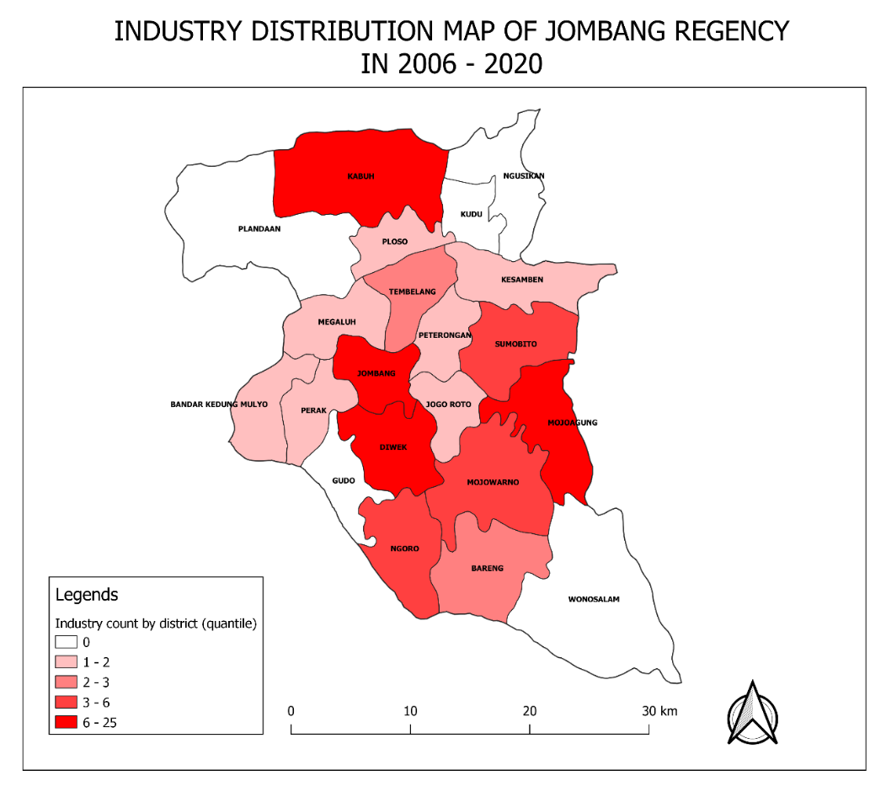
Based on Figure 1, there are 5 sub-district that have no industry type UKL-UPL document submissions which are Plandaan, Kudu, Ngusikan, Gudo, and Wonosalam. Second category consists of 7 sub-districts with 1 – 2 industry type UKL-UPL document submissions, followed by third and fourth categories which consist of 2 and 3 sub-districts respectively. There are 4 sub-districts that fall into last category which has 6 – 25 industry type UKL-UPL document submissions, they are Kabuh, Jombang, Diwek, and Mojoagung sub-districts.
Figure 1. Industry Distribution Map of Jombang Regency in 2006 – 2020

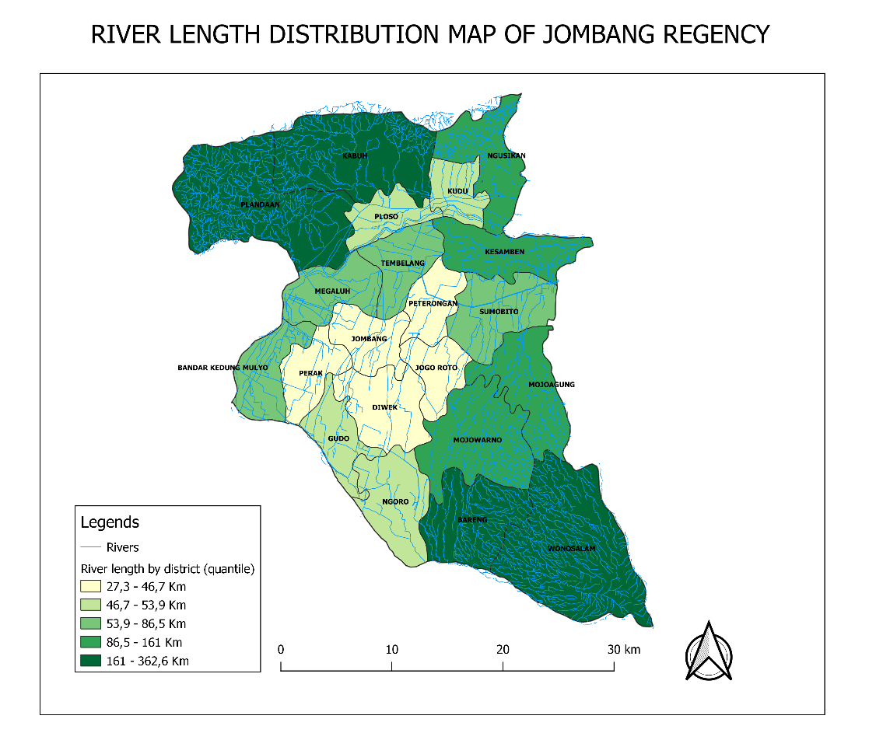
Figure 2 divide Jombang Regency’s districts into 5 catagories by its river length using quantile mode, the least green colored sub-district have shortest river length and most green sub-district have the longest river length. The first category has the shortest river length than the other four, sub-district that fall under this category are Perak, Jombang, Diwek, Jogo Roto, and Peterongan. Second category has. And the last category has the longest river length than the rest that consists of Plandaan, Kabuh, Bareng, and Wonosalam sub-district. Based on Figure 1 and 2, sub-district with longest river length category has lesser/no industry count than other less categories which are Bareng, Plandaan, and Wonosalam. Sub-district with shortest river length category has the most industry than the other longer categories which are Jombang and Diwek.
Figure 2. River Length Distribution Map of Jombang Regency

Table 1. Jombang’s Industry Establishment Plan Locations to Nearest River Measurement Result
Distance Categories |  | Industry Pollutant |  |  | Total | Precentage (%)
 | Liquid Pollutant Potential |  | No Liquid Pollutant Potential
 | Industry | Precentage (%) | Industry | Precentage (%)
1 – 250 m | 52 | 60 | 20 | 61 | 72 | 60.5
251 – 500 m | 22 | 26 | 5 | 15 | 27 | 22.6
501 – 750 m | 7 | 7 | 6 | 18 | 13 | 10.9
751 – 1000 m | 5 | 5 | 2 | 2 | 7 | 0.06
Based on Table 1, the nearest river length of industries with liquid pollutant potentials are divided into 5 categories based on their measured length, each category has 250 meters interval starting from 1 meter to 1000 meter. Both industries with liquid pollutant potential and no liquid pollutant potential are fall under the first category (1 – 250 m) with 60% and 61% percentage of all industries respectively. That means more than half of industries with and without liquid pollutant potential locations are less than 250 meters from nearest river. Table 2 shows which sub-districts industry with liquid pollutant potential prencentages, resulting Kesamben and Perak sub-districts have perfect percentage of industry with liquid pollutant potential in UKL-UPL documents submitted for those area. Table 3 is the result of indepentent T test to see how significant the differences in industry locations to the nearest river for industry with and without liquid pollutant potential.

Table 2. Jombang’s Industry Establishment Plan with Liquid Pollutant Potential Counts by District
Sub-districts | Industries with Liquid Pollutant Potential
 | Total Industries | With Liquid Pollutant Potential | Precentage of Industries with Liquid Pollutant Potential (%)
Bandar Kedung Mulyo | 2 | 1 | 50
Bareng | 6 | 3 | 50
Diwek | 12 | 10 | 83.3
Gudo | 0 | 0 | -
Jogo Roto | 3 | 2 | 66.7
Jombang | 30 | 25 | 83.3
Kabuh | 9 | 8 | 88.9
Kesamben | 2 | 2 | 100
Kudu | 0 | 0 | -
Megaluh | 3 | 1 | 33.3
Mojoagung | 15 | 11 | 73.3
Mojowarno | 10 | 6 | 60
Ngoro | 6 | 4 | 66.7
Ngusikan | 0 | 0 | -
Perak | 2 | 2 | 100
Peterongan | 3 | 2 | 66.7
Plandaan | 0 | 0 | -
Ploso | 4 | 2 | 50
Sumobito | 6 | 4 | 66.7
Tembelang | 6 | 3 | 50
Wonosalam | 0 | 0 | -

Table 3. Jombang’s Industry Establishment Plan with and without Liquid Pollutant Potential Locations to Nearest River Independent T-Test Results
 | t | df | Sig (2 tailed) | Mean Diff. | Std. Error Difference
Industry Establishment Plan with and without Liquid Pollutant Potential Locations to Nearest River | -0.110 | 117 | 0.912 | -5.427 | 49.185

Industrial establishment plans on Jombang Regency are mostly centered around it’s regency seat. This is shown in the results of the mapping of industry type UKL-UPL documents and Jombang district spatial data with sub-district around Jombang are almost all having atleast three UKL-UPL documents submitted. The study is in line with other studies that shows there are grouping of industrial locations in the region around the district capital includes 2 sub-sub-district and 2 villages (Supartiningtias and Suprajaka, 2015). There is also a study about industrial density in sub-district level of Bekasi showing that Cikarang Utara and Cikarang Selatan sub-district have the most dense area on that district where that locations are in regency seat (Saleh and Warlina, 2017). The grouping and density of industry in a region is influenced by many factors such as economic scale, regional income, availability of raw materials, and labor costs. (Nugraha, 2015; Riebe et al., 2015). Geographically, there are 6 parameters that important in industrial development estates which are land use, land slope, soil types, distance to road, distance to river and distance to infrastructure centers. The selection of the designation of industrial activities should be on land area that has a relatively flat topography (0-30% slope) (Nugraha, 2015). This is in accordance with the findings with this study that most industrial establishment plans on Jombang Regency are on sub-districts with slope area less than 30% which are Kabuh, Jombang, Diwek, and Mojoagung sub-districts. But there is one sub-district that not in line with this statement which is Mojoagung, this region has slope area more than 40% despite having high number of industrial establishment plan (BPS Jombang, 2016). The road network for industrial activities has a very important function especially in the context of the ease of movement mobility and the level of achievement (accessibility) both in the supply of raw materials, human movement, and marketing of production products. Good road network for industrial activities, must take into account the capacity and number of vehicles that will go through the road so that it can be anticipated from the beginning of the possibility of damage to roads and congestion (Nugraha, 2015). Jombang’s regency seat have better transportation access compared to the other sub-districts based on how many routes are available for rustic transportation (BPS Jombang, 2020). This finding is inline with industrial distribution research conducted in Cikupa, Tangerang, which shows that heavy industries are suitable to be established near generic routes because the loaded material really depends on the road condition (Supartiningtias and Suprajaka, 2015).

River is a big and lengthens water stream that flow continuously from upstream towards downstream. Water in the river is generally collected from precipitation, such as rain, dew, springs, underground runoff, and in some certain countries also come from melting ice / snow. Besides water, the river also drains sediment and pollutants (Yusup and Farhan, 2020). The length of rivers in Jombang tend to be longer in the northen and sourthern sub-districts (161 - 362.2 Km), and shorter in the middle of the regency (27,3 – 46,7 Km). The northen and southern districs of Jombang Regency has higher altitude than the other districs because it is mountains area. Sub-districts with longer river length have lesser or no industry establishment plan, and district with shorter river length have more industry establishment plan on the UKL-UPL documents. This might be happened because the area with longer river length is a mountain area which are not suitable for industry establishment in Jombang regency. This finding in line with a study on a steep mountain slopes that increase in altitude increasing average hillslope (Riebe et al., 2015). As mentioned before that flat topography/land slope is one of crucial parameters for the development of industrial estates (Nugraha, 2015).

Most industry type UKL-UPL documents (60%) in Jombang Regency fall into first category which industry location having 1 to 250 meters to the nearest river for both industries that have/don’t have liquid pollutant potential. The second category is for industry location having 251 to 500 meters to the nearest river, there are 15% and 26% documents from total UKL-UPL documents. According to the results of t-test of industry with liquid pollutant potential’s location to nearest river, there is no significant difference between industries that have liquid pollutant potentials and industries that do not have liquid pollutant potentials to the nearest river (0.912 < 0.05). There are no articles explaining association betwen industry establishment plan location to the nearest river to be found yet, but river water quality in an industrial area in Indonesia has been found to be exceeding the turbidity and color limit set by local governor and Indonesia’s Health Ministry (Rosyidah, 2018). A study analyzed river water samples at a point of 100 meters from the disposal of liquid waste of a rubber industry and found that the content of TSS, ammonia, total nitrogen, and COD has high pollution levels, then the pH of water and BOD content is normal and moderate if using standard No. 010/Permen.L.H/2006 respectively. The bad parameter of water quality is commonly caused by the activity of industry that do not conduct proper wastewater treatment nor following government policy before being discharged into the river (22-23). According to PERMENLHK No. P93 tahun 2018, an industry that has waterwaste is required to have a water treatment plant. Monitoring aims to oversee the state of waterwaste so that it met to applicable regulation (Mawardi and Pertiwi, 2020). Therefore, Jombang Regency’s Environment Office has been continuously doing environmental risk asessment twice a year around river in industrial area. The decrease in the quality of water will reduce its usefulness, productivity, and carrying capacity and capacity of water resources which will eventually worsen the wealth of natural resources (Schwarzenbach et al., 2010). In general, the river in Indonesia is often used by the people in everyday life for the activity of washing clothes, washing vehicles, bathing, washing and latrine activities. Poor river water quality can cause health problems in the community around the river that utilize the river, for example diarrhea, dermatitis, and skin disorder. The existence of heavy metals in waters is very dangerous against the life of a waters, which further influences indirectly to human health. This is related to the properties of heavy metals that are difficult to degrade. Heavy metals can accumulate in aquatic biota such as shellfish, and fish and inside sediment (Firmansyah et al., 2021).

CONCLUSION
This study shows more than a half of industrial type UKL-UPL submitted in Jombang Regency have their industry located close to the rivers. Even though the place with high industry counts has shorter river length, regular river water quality monitoring is required to be done by both company and government so that it doesn’t exceed environmental quality standards and cause health problems, especially for those industries very close to river because river water is still used by many communities around river in Indonesia for various activities.
ACKNOWLEDGEMENT

The author wants to give thank to Mrs. Lilis Sulistyorini for aiding and guiding in finishing this study, and Mr. Muhammad Rosyid Ridlo who provided industrial establishment data from related region. Not to forget all organizations/institutes who have been providing data used in this study at zero cost.

REFERENCE
- Aqli, W. (2010) ‘Analisa Buffer Dalam Sistem Informasi Geografis Untuk Perencanaan Ruang Kawasan’, Inersia, 6(2), pp. 192–201. doi: 10.21831/inersia.v6i2.10547.
- Bappeda Jawa Timur (2013) Potensi dan Produk Unggulan Kabupaten Jombang, Jawa Timur. BAPPEDA JATIM. Available at: http://bappeda.jatimprov.go.id/bappeda/wp-content/uploads/potensi-kab-kota-2013/kab-jombang-2013.pdf. (Accessed on 10th March 2021)
- Belladona, M. (2017) ‘Analisis Tingkat Pencemaran Sungai Akibat Limbah Industri Karet Di Kabupaten Bengkulu Tengah’, Seminar Nasional Sains dan Teknologi Fakultas Teknik Universitas Muhammadiyah Jakarta, (November), pp. 1–7.
- Damayanthi, V. R. (2008) ‘Proses Industrialisasi Di Indonesia Dalam Prespektif Ekonomi Politik’, Journal of Indonesian Applied Economics, 2(1), pp. 68–89. Available at: http://jiae.ub.ac.id/index.php/jiae/article/view/183/165.
- DIARI SANDI, R. and HARIYANTO, B. (2019) ‘Analisis Kualitas Air Dan Distribusi Limbah Cair Industri Tahu Di Sungai Murong Kecamatan Jogoroto Kabupaten Jombang’, Swara Bhumi, 1(2).
- Dinas Lingkungan Hidup Jatim (2018) Indeks Kualitas Air - Dinas Lingkungan Hidup Provinsi Jawa Timur. Available at: https://dlh.jatimprov.go.id/berita-kualitas-air.html.
- Firmansyah, Y. W. et al. (2021) ‘DAMPAK PENCEMARAN SUNGAI DI INDONESIA TERHADAP GANGGUAN KESEHATAN : LITERATURE REVIEW Impact of River Pollution In Indonesia on Health Problems : A Literature Review’, JURNAL RISET KESEHATAN, 13(1).
- Jombang, B. P. S. (2020) Angkutan Pedesaan Menurut Route Trayek Jombang. Available at: https://jombangkab.bps.go.id/statictable/2015/03/2.
- Kementrian Lingkungan Hidup dan Kehutanan (2010) ‘Peraturan Menteri Negara Lingkungan Hidup Nomor 13 Tahun 2010’.
- Kemiringan Tanah Kab. Jombang Tahun 2016 (2016) https://jombangkab.bps.go.id/statictable/2017/05/30/95/kemiringan-tanah-kabupaten-jombang.html. (Accessed on 10th March 2021)
- Mawardi, L. and Pertiwi, M. (2020) ‘Sistem Monitoring Limbah Industri Rayon’, Prosiding Seminar Nasional Teknik Elektro Volume 5 Tahun 2020, 5, pp. 1–4.
- Muliani, A. and Rijal, M. (2018) ‘Industrialisasi, Pencemaran Lingkungan Dan Perubahan Struktur Kesehatan Masyarakat’, Biosel: Biology Science and Education, 7(2), p. 178. doi: 10.33477/bs.v7i2.654.
- Mushthofa, A., Rudiyanti, S. and Muskanonfola, M. R. (2014) ‘ANALISIS STRUKTUR KOMUNITAS MAKROZOOBENTHOS SEBAGAI BIOINDIKATOR KUALITAS PERAIRAN SUNGAI WEDUNG KABUPATEN DEMAK’, Management of Aquatic Resources Journal (MAQUARES), 3(1), pp. 81–88. doi: 10.14710/marj.v3i1.4289.
- Nasir, M., Fatkhurohman and Muqorobin, A. (2011) ‘Problem Manajemen Lingkungan dan Isu Industrialisasi’, Prosiding Seminar Nasional & Internasional, 1(1), pp. 163–172. Available at: https://jurnal.unimus.ac.id/index.php/psn12012010/article/view/420.
- Nugraha, W. S. (2015) ‘PENENTUAN LOKASI POTENSIAL UNTUK PENGEMBANGAN KAWASAN INDUSTRI MENGGUNAKAN SISTEM INFORMASI GEOGRAFIS DI KABUPATEN BOYOLALI’, Jurnal Geodesi Undip, 4, pp. 194–202.
- Riebe, C. S. et al. (2015) ‘Climate and topography control the size and flux of sediment produced on steep mountain slopes’, Proceedings of the National Academy of Sciences of the United States of America, 112(51), pp. 15574–15579. doi: 10.1073/pnas.1503567112.
- Rosyidah, M. (2018) ‘Analisis Pencemaran Air Sungai Musi Akibat Aktivitas Industri (Studi Kasus Kecamatan Kertapati Palembang)’, Jurnal Online Universitas PGRI Palembang, 3(1), pp. 21–32.
- Saleh, B. and Warlina, L. (2017) ‘Identifikasi Karakteristik Aglomerasi Industri Pengolahan Di Cikarang Kabupaten Bekasi Tahun 2006 Dan 2013’, Jurnal Wilayah dan Kota, 4(01), pp. 37–53. doi: 10.34010/jwk.v4i01.2119.
- Schwarzenbach, R. P. et al. (2010) ‘Global water pollution and human health’, Annual Review of Environment and Resources, 35, pp. 109–136. doi: 10.1146/annurev-environ-100809-125342.
- Supartiningtias, J. and Suprajaka, S. (2015) ‘Evaluasi Spasial Pola Sebaran Industri Di Kecamatan Cikupa, Kabupaten Tangerang’, Planesa, 5(02).
- Tilaar, S. (2010) ‘Tinjauan Sebaran Lokasi Aglomerasi Industri Di Indonesia’, Tekno, 8(52), pp. 90–96.
- Uyara, L., Kunu, P. and Talakua, S. M. (2017) ‘Studi Perbandingan Kualitas Air Bersih Dalam Kaitanya Dengan Aktivitas Masyarakat Di Sekitar Sumber Air Pada Desa Wainitu, Batumerah, Amahusu, Dan Halong’, Jurnal Budidaya Pertanian, 13(2), pp. 111–119. doi: 10.30598/jbdp.2017.13.2.111.
- Waluya, B. (2010) ‘ANALISIS GEOGRAFIS KONSENTRASI INDUSTRI KULIT DI KABUPATEN GARUT’, Jurnal Geografi Gea, 10(2). doi: 10.17509/gea.v10i2.1078.
- Widiyanto, A. F., Yuniarno, S. and Kuswanto (2015) ‘LAND WATER POLLUTION FROM INDUSTRIAL WASTE AND’, Jurnal Kesehatan Masyarakat, 10(2), pp. 246–254.
- Yogafanny, E. (2015) ‘Pengaruh Aktifitas Warga di Sempadan Sungai terhadap Kualitas Air Sungai Winongo’, Jurnal Sains &Teknologi Lingkungan, 7(1), pp. 29–40. doi: 10.20885/jstl.vol7.iss1.art3.
- Yusup, K. D. and Farhan, O. (2020) ‘Analisis Hidrologi Sungai Pemali Kabupaten Brebes’, Jurnal Konstruksi, 7(2), pp. 2085–8744. Available at: http://jurnal.ugj.ac.id/index.php/Konstruksi/article/view/3894.

